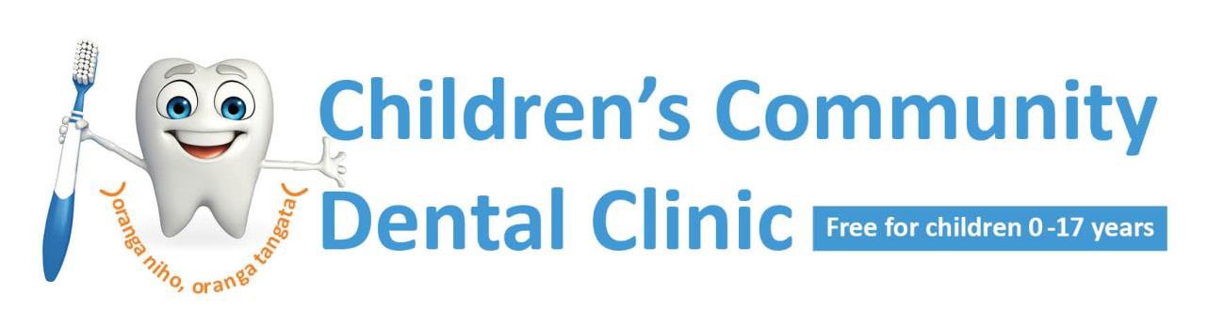
Tuesday, 18 August 2020

To our Auckland whānau

With the change in COVID-19 alert levels to Level 3 across the Auckland region, the wellbeing of our
community is paramount.
Practicing guidelines set jointly by the Ministry of Health and Dental Council of New Zealand state that all routine dental treatment should be postponed. Therefore, the Children’s Community Dental Service (Auckland Regional Dental Service) is only able to provide urgent and emergency dental care to children, once the child’s condition has been assessed by a dental clinician over the phone.
The Dental Council of New Zealand has further advised that if a child’s dental condition can be accurately diagnosed and effectively managed without needing to see the child in-person, then that is best. This means the child’s dental condition may be able to be managed with medication alone.
From 12 August 2020, we will have seven essential dental care clinics open across Auckland (please find the list below). Opening hours are Monday-Friday, 8am-4.30pm.

Clinic name | Direct dial | Direct email
Silverdale | 09 426 8470 | ARDS.Silverdale@waitematadhb.govt.nz
Glenfield Intermediate | 09 444 6160 | ARDS.GlenfieldIntermediate@waitematadhb.govt.nz
Henderson Intermediate | 09 838 9571 | ARDS.HendersonIntermediate@waitematadhb.govt.nz
Point England | 09 570 4309 | ARDS.PointEngland@waitematadhb.govt.nz
Browns Road, Manurewa | 09 264 0047 | ARDS.BrownsRoad@waitematadhb.govt.nz
Buckland Road, Mangere | 09 442 7208 | ARDS.BucklandRoad@waitematadhb.govt.nz
Pukekohe Intermediate | 09 237 1070 | ARDS.PukekoheIntermediate@waitematadhb.govt.nz

If your child is in pain or you have concerns about their teeth, please phone the nearest clinic to you from the list provided above. Our dental clinicians will be available to discuss your concerns with you and to make a plan for your child.
If you need to contact a health professional outside our operating hours, please phone Healthline on 0800 611 116.
We kindly request you do not present to the clinic unless you have phoned the clinic and have been offered an appointment. Please note that we are required to ask COVID-19 pre-screening questions prior to all children and their whānau attending an appointment in our dental clinics.
Please review our website for further updates to our service delivery:
http://www.waitematadhb.govt.nz/hospitals-clinics/clinics-services/dental-oral-health/

Thank you for your continued support,
The Children’s Community Dental Service.

Adelle Rongokea Dr Kirsten Miller
Unit Manager – ARDS Acting Clinical Director – ARDS
Waitematā DHB Waitematā DHB

